Application Form 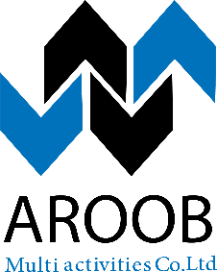
Office No1, Second floor, Building No 1043,
Alsiteen Street, Khartoum – Sudan
Please complete this application fully. If you have any difficulties in doing so please do not hesitate to contact us.

ID Details All information contained in this document will remain strictly confidential.

Contact Details

Address Details

